Name – Rachit Sharma , SAP ID – 500121957, Batch – B2 DevOps

Experiment: Deploying a Containerized Application using AWS ECR and ECS

Objective
To build, push, and deploy a Docker container using AWS Elastic Container Registry (ECR) and Elastic Container Service (ECS).

Prerequisites
- AWS account
- IAM permissions
- Docker installed
- AWS CLI configured

Procedure
Step 1: Login to AWS Console and select region US East (N. Virginia).

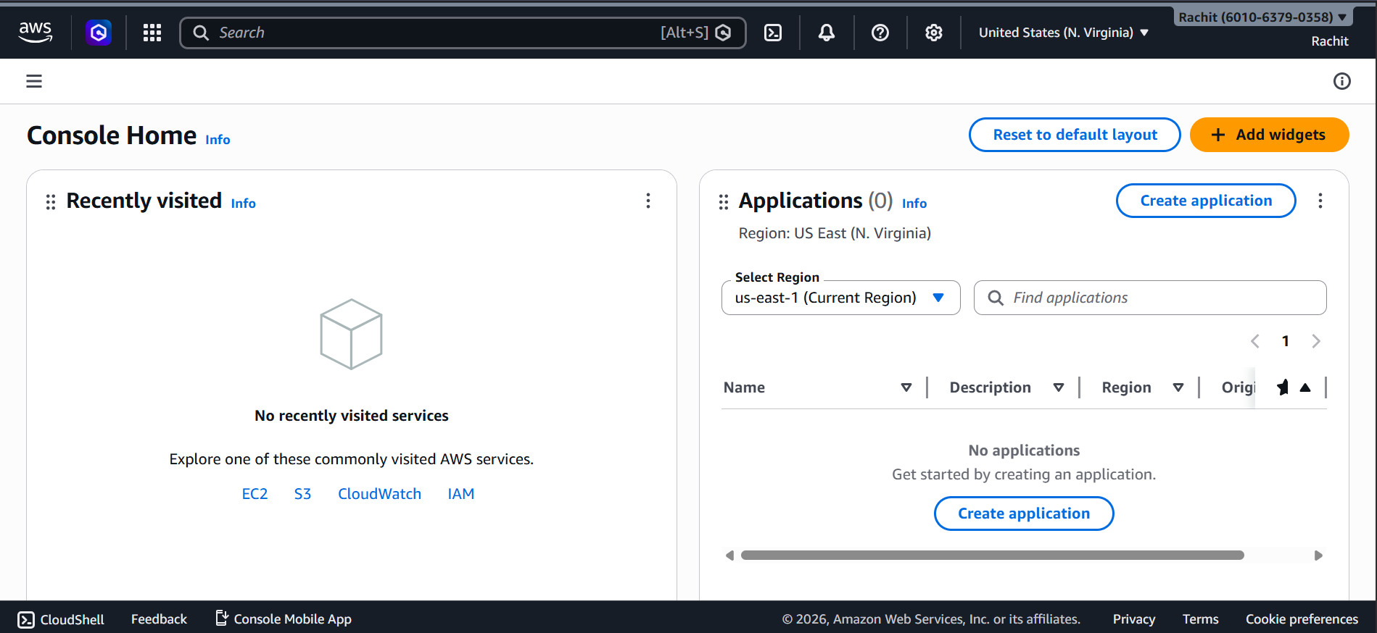

Step 2: Open Elastic Container Registry (ECR) from services.
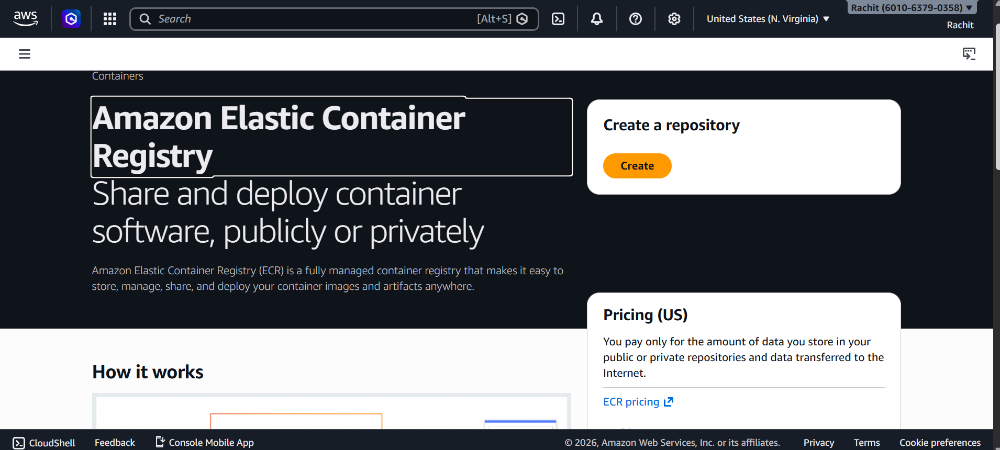
Step 3: Create a new repository with default settings.
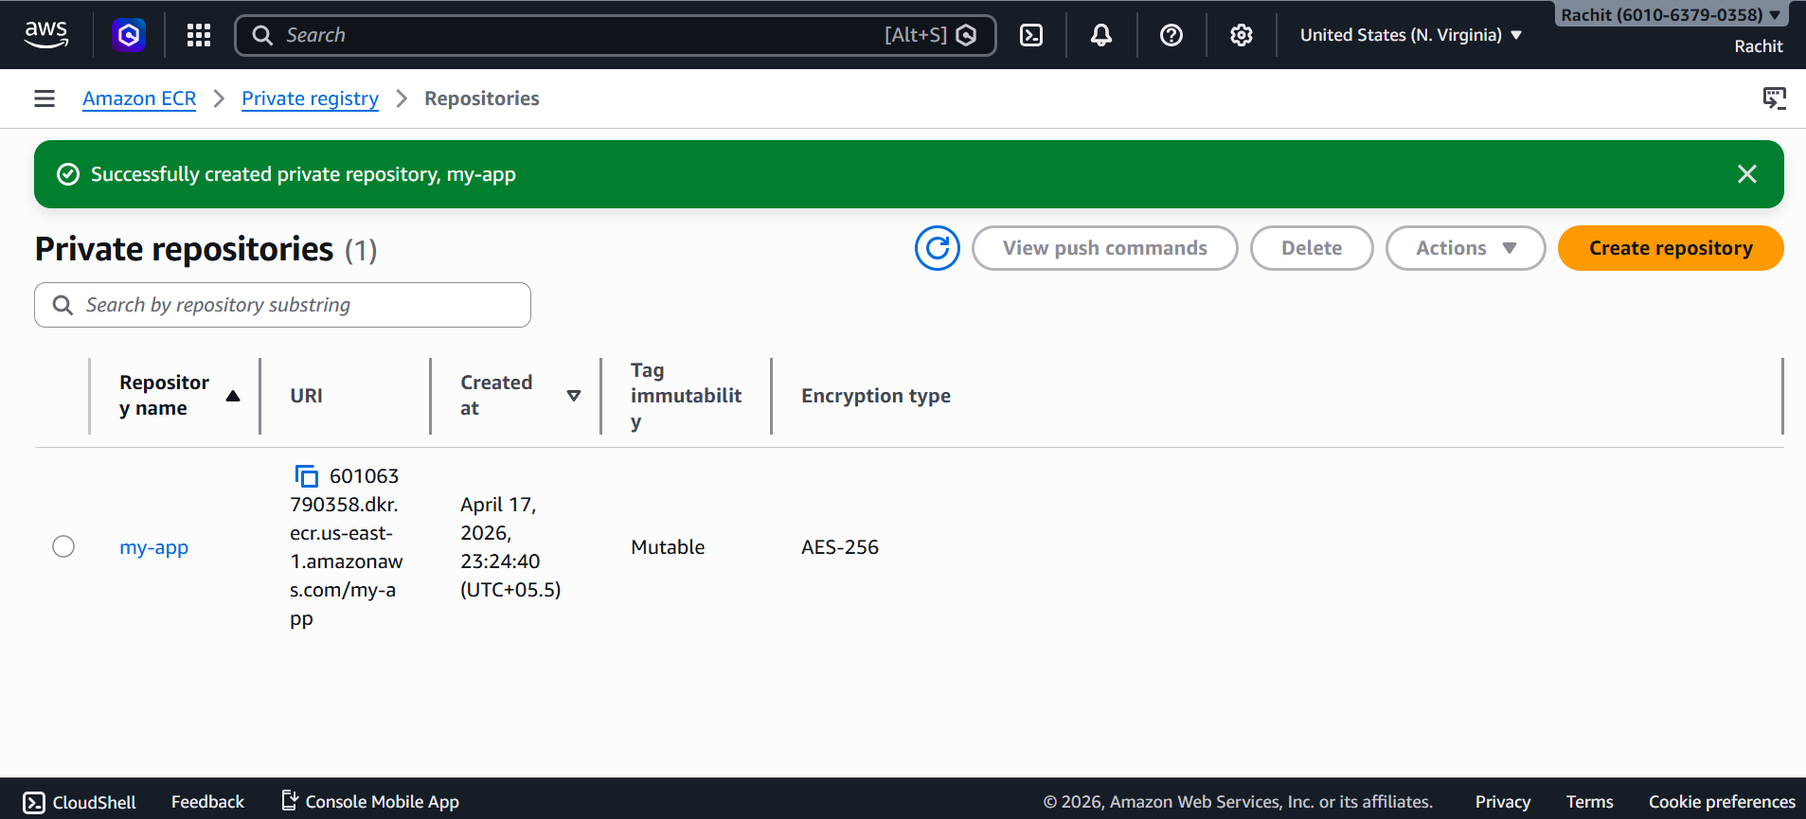

Step 4: Authenticate Docker to ECR using AWS CLI.
Step 5: Build Docker image using docker build command.
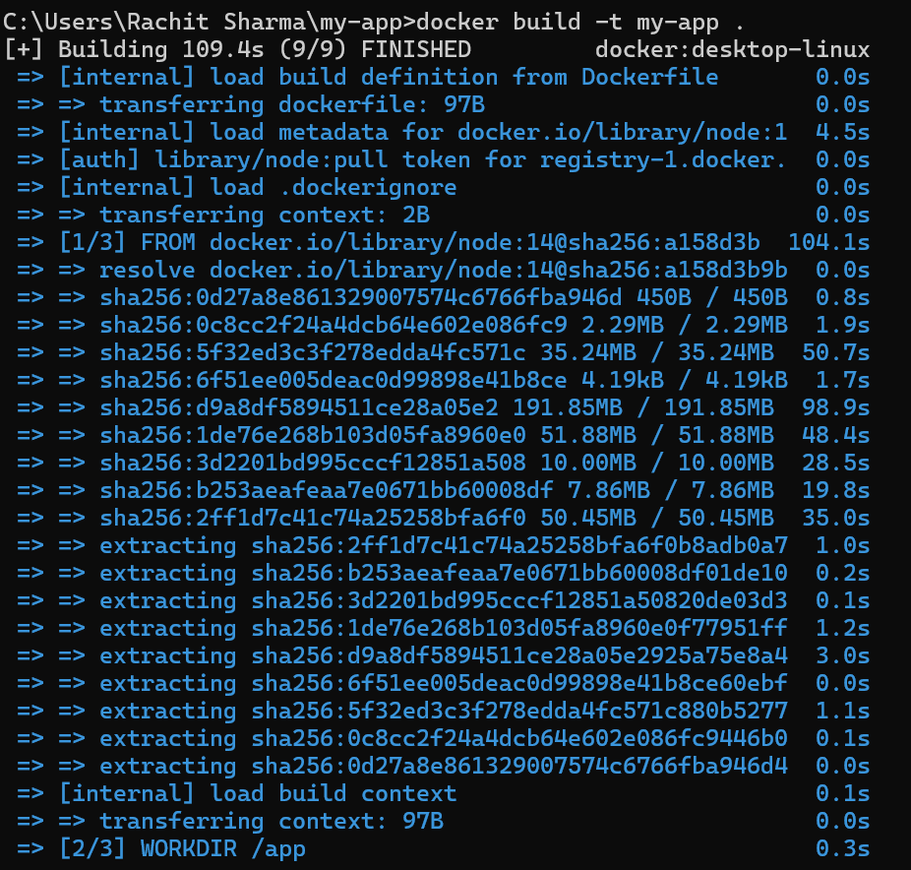

Step 6: Tag the Docker image with repository URI.
Step 7: Push the Docker image to ECR.
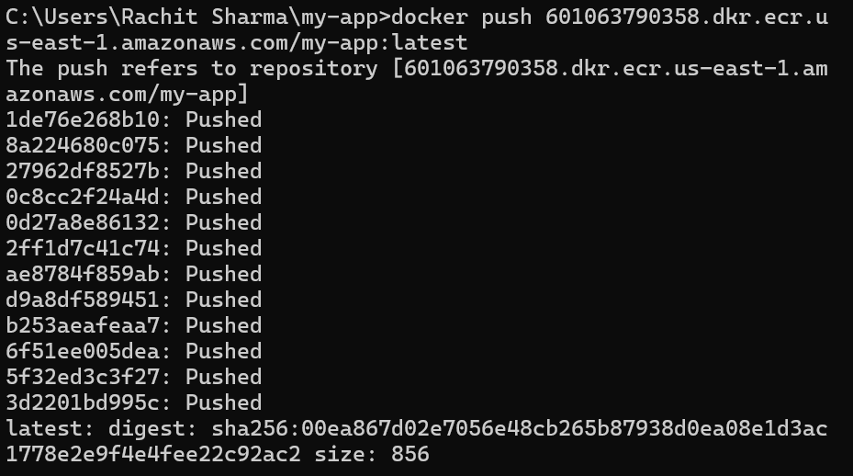

Step 8: Go to ECS and create a new cluster.
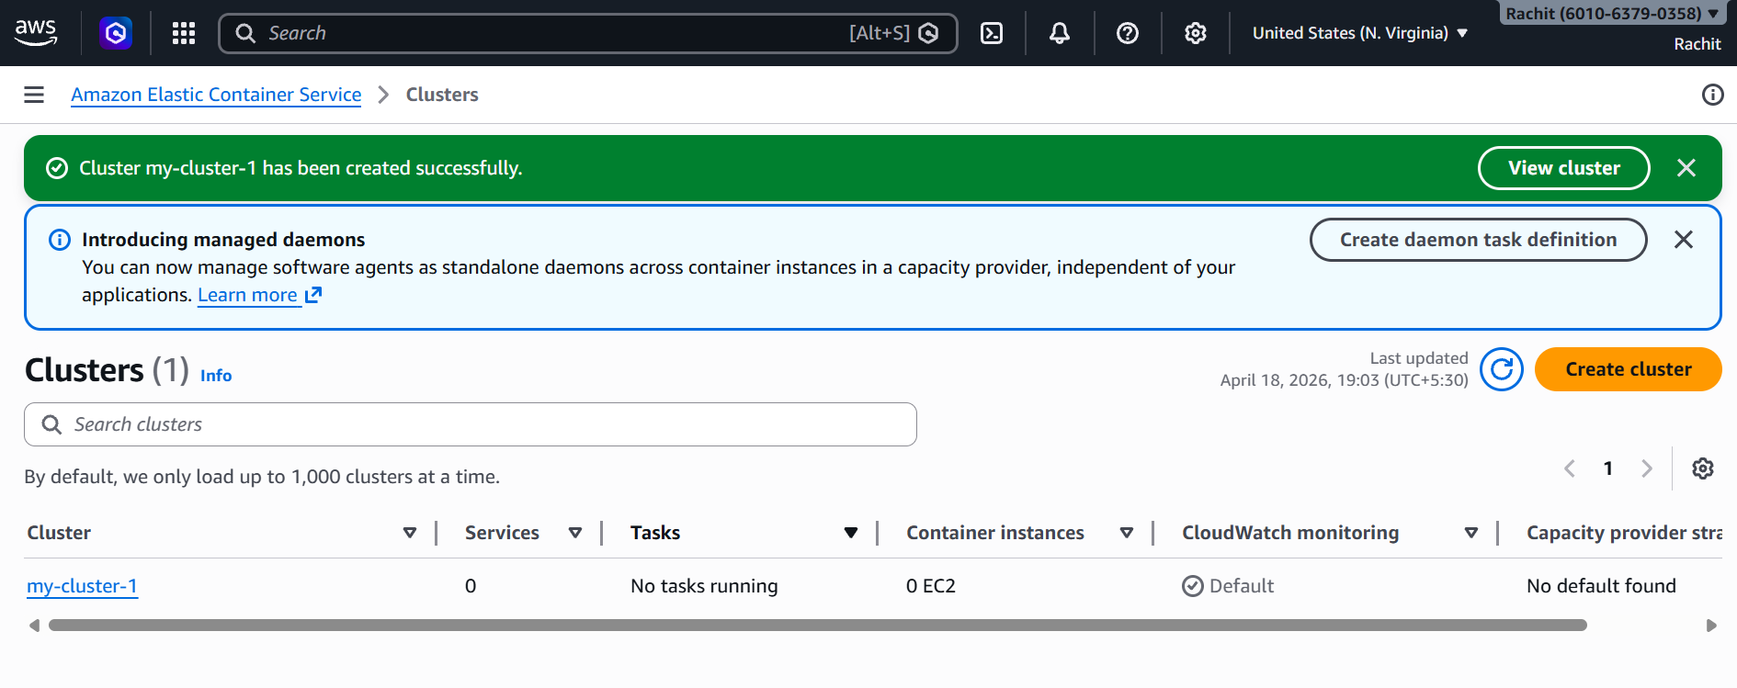
Step 9: Create a task definition and add container using ECR image.
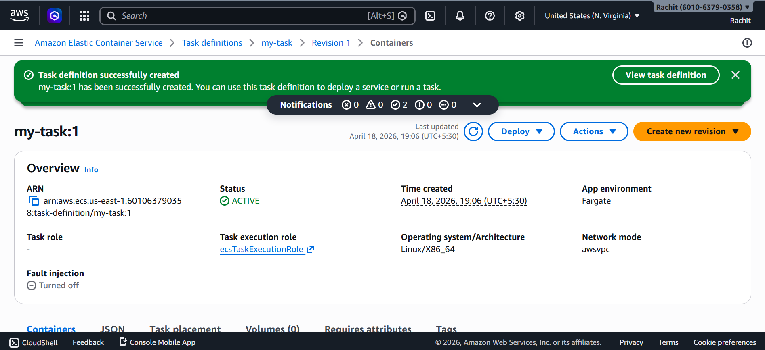

Step 10: Run a service in ECS cluster to deploy container.
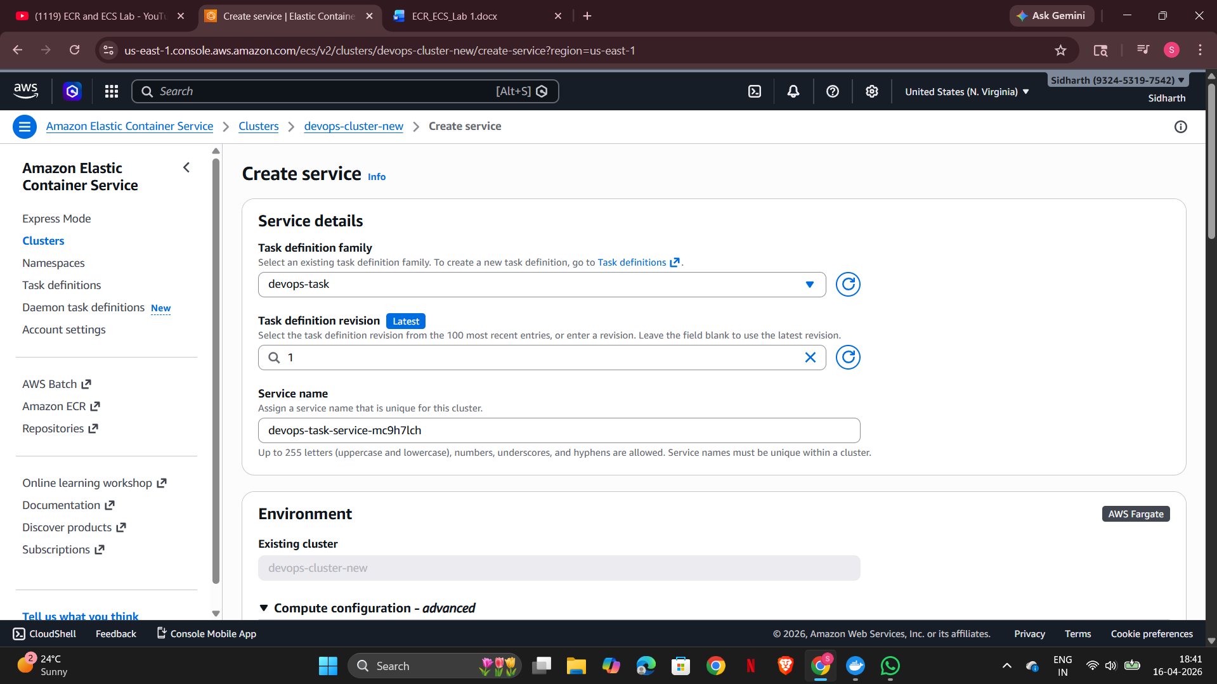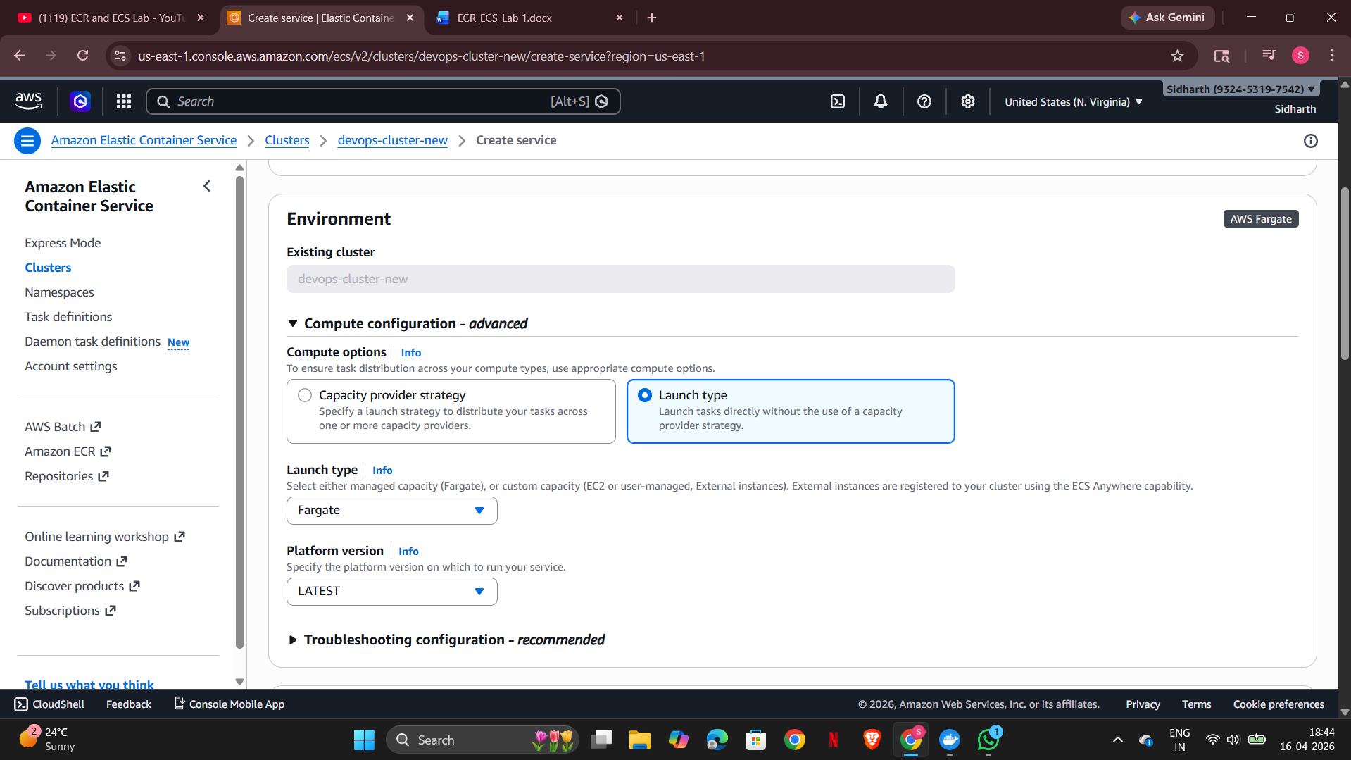

Expected Output
Container runs successfully on ECS.
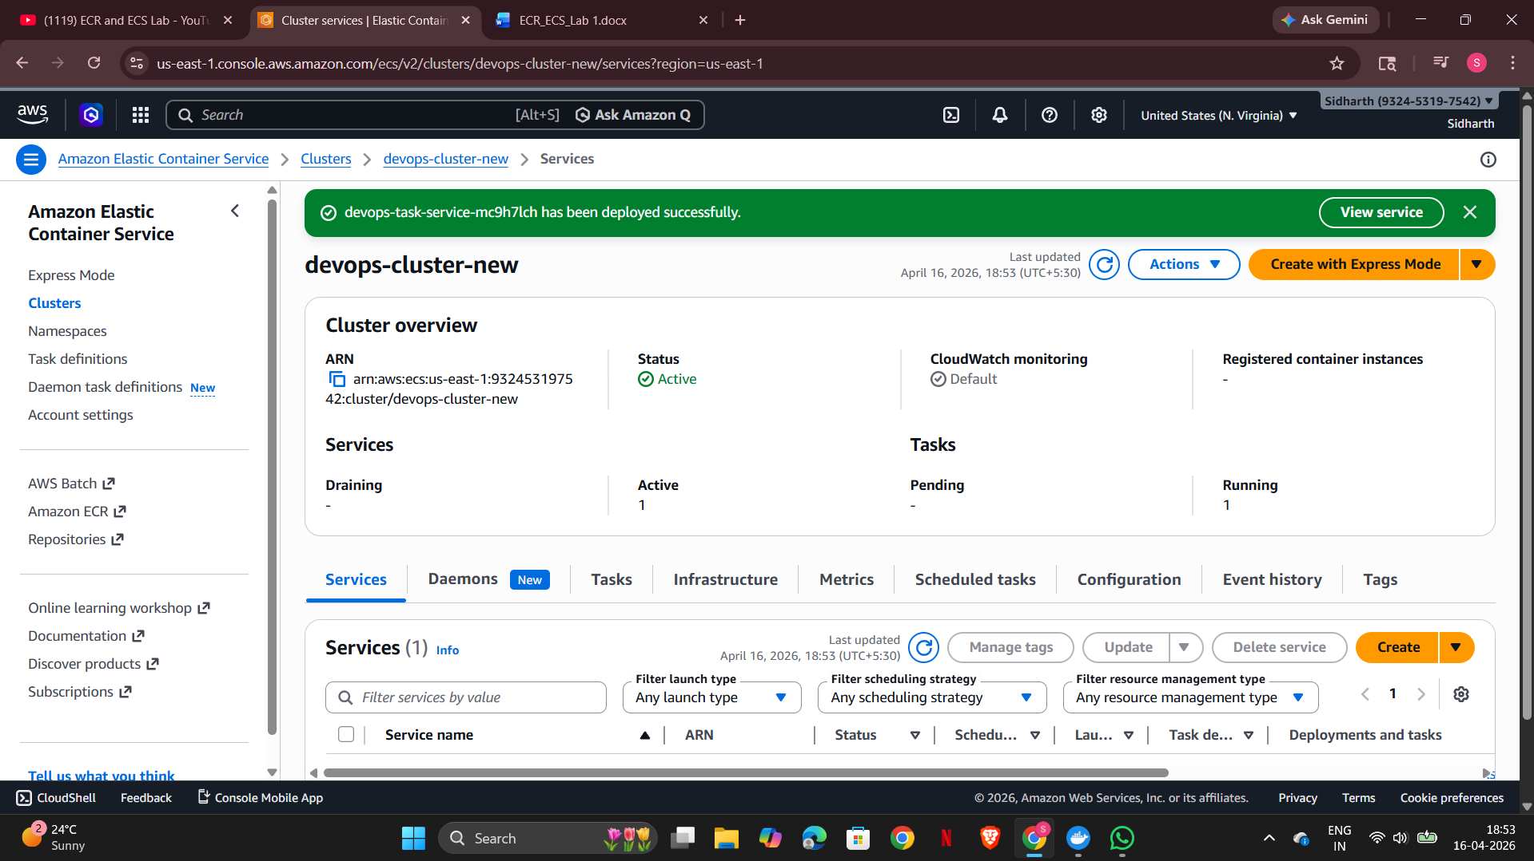

Conclusion
Successfully deployed a containerized application using AWS ECR and ECS.
